# xpedx.com Next generation

# *UOM Calculation And Presentation Design Document*

**Authors: Sterling Commerce**

**Date Created:** 05/04/10

**Last Updated:** 06/17/10

**File Name:** C:\Documents and Settings\bfurman\My Documents\Temp\Methodology v1.1\Project Management\TEMPLATE - DOCUMENT - Use Case Definition.docxpedx UOM Calculation And Presentation Detail Design v1.6.doc

Approval Signatures (Mandatory)

|  |  |  |  |  |
| --- | --- | --- | --- | --- |
| **Title** | **Name** | **Signature** | **Date** | **Comments / Issues / Concerns** |
| **xpedx Owner(s)** | Steve Bugher |  |  |  |
| Cheryl Tullis |  |  |  |
| **Sterling Commerce Owner(s)** | Guy Read |  |  |  |
|  |  |  |  |

**Note**: The sign off indicates approval of all sections of the document.

Document Revision History

This chart tracks the changes introduced by the revisions to the document as the project progresses through the stages of the System Development Life Cycle (SDLC).

| Version | **Date** | **Description (Changes Made)** | **Author(s)** |
| --- | --- | --- | --- |
| 1.0 | 05/04/2010 | Initial Draft | Sterling |
| 1.1 | 05/07/2010 | Ready to deliver | Sterling |
| 1.2 | 05/31/2010 | Incorporated feedbacks from xpedx | Sterling |
| 1.3 | 06/02/2010 | Incorporated changes from 6/1/10 meeting with Steve, George and Chris, Cheryl and Jasmine | Sterling |
| 1.4 | 06/06/2010 | Incorporate changes for price calculation for TH and CW UOMs. | Sterling |
| 1.**5** | 06/15/2010 | Price Calculation logic for TH, CW is revised as per xpedx feedback | Sterling |
| 1.6 | 06/17/2010 | UOM Update 2 v 3 and Minor Updates | Sterling |

Related or Reference Documents

| Document Name | Description | Owner | Location |
| --- | --- | --- | --- |
| SCI_Xpedx Solution Definition Document v1.5 | Solution Definition document | Sterling Commerce |  |
|  |  |  |  |

TABLE OF CONTENTS

1. Introduction 5

1.1 Document Purpose 5

1.2 Document Audience 5

2 UOM Calculation And Presentation 6

2.1 Functions & Solution 6

2.1.1 Order UOMs and Conversions. 6

2.1.2 Base and Pricing UOM 6

2.1.3 EDI / B2B UOM Calculation 6

2.1.4 Customer X ref and UOM Calculation 7

2.1.5 Order Multiple UOM Calculation 7

2.1.6 Customer UOM Preferred Table 8

2.1.7 Pricing UOM 10

2.2 Master System 10

2.3 Implementation Details 10

2.3.1 Entity objects. 10

2.3.2 Actions classes involved 11

2.4 Process Flow 11

2.5 Screen Shot 12

2.6 Open Questions 15

2.7 Assumptions 15

3 Glossary of Terms 16

# Introduction

## Document Purpose

This document is the governing functional design document for UOM Calculation and Presentation functionality. It presents significant decisions and constructs used in developing the functionality. Testing, builds, configuration management are not covered in this document.

The document will also serve the purpose of keeping a list of assumptions that were made during design discussions.

## Document Audience

This document is intended for management and technical staff working on this project, xpedx IT and Business, webMethods, Legacy(MAX and ACCESS), HP, IW, xpedx/IP Network Team. Sterling will use the document during design and configuration for design consideration.

# UOM Calculation And Presentation

## Functions & Solution

Unit of Measure is used to define standard units of measure to associate with your items and locales. The Sterling Multi-Channel Fulfillment Solution provides unit of measure classifications for dimension, volume, weight, and time. In addition to defining new units of measure, the Sterling Multi-Channel Fulfillment Solution provides the ability to create conversion rates between different units of measure.

## Order UOMs and Conversions.

From Content Director Catalog Master Load, each item will have list of ordering UOMs with their conversion factor to the base unit of measure. The conversion factors are shown in parenthesis against the UOM in the drop down. This is the list which gets populated along with the customer UOM in the drop down in the following pages:

* Product Detail Page
* Shopping Cart page
* My Items List Page
* Quick Add Widget
* Catalog ‘lightbox’

## Base and Pricing UOM

Base unit is the unit in which items are stocked. The minimum unit how item is stocked. Order minimum values are in Base UOM. All the conversion factors are w.r.t to base UOM. Base UOM information will be populated for every item from Content Director Catalog Master Load. There is only one Base UOM per item.

Pricing UOM is the UOM in which the list price is stored in Sterling.

## EDI / B2B UOM Calculation

Some B2B Customers user 3 digit UOMs from the printed documents (These documents are invoices, shipper and some contract reports) sent by Legacy and sent those UOMs during P&A and Order Placement.

If the customer has a 2 digit UOM then Sterling will convert this to a 3 digit Legacy UOM using the Legacy UOM (that is valid UOM per item master) for the item conversion per the “xpedx Batch Feeds – Legacy UOM”.

Per the SDD (v1.4)

The processing of UOMs is done in the following order of priority on all orders and in the catalog (b2b and interactive):

* If an item is present that has a Customer Contract UOM, it takes the highest precedence and is the only UOM in which the customer is allowed to order. These are passed onto the backend in Interface calls (e.g. P&A, Order Placement) as is without converting to base units, since the Legacy is capable of handling them.
* If an item is present that doesn’t have a Customer Contract UOM, but has a Customer-preferred UOM, the UOM is replaced with its corresponding xpedx UOM. The Legacy has no knowledge of the customer-preferred UOM.
* If an item is present that has neither of the two preceding types of UOMs, use the xpedx UOMs as default.

## Customer X ref and UOM Calculation

There is a flag called exclusive on customer specific UOM in legacy, if checked only show this UOM for the item. If the flag is not checked than the customer will see all the available UOM plus this UOM. List of all the UOM will come from master data and customer specific will come from customer xref. Depending on the flag we will see do we need to do union or just show the specific UOM from cust xref file.

There can be an exclusive customer UOM, if this is defined, only show the one UOM. If a customer UOM is defined, but it isn’t flagged as exclusive, then union this with the other avail UOM’s are shown.

For example:

Customer defined UOM for an item is EA (EACH). Other available UOM are CT, ST.

If exclusive flag is checked then just show EA.

If exclusive flag is not checked then show EA, CT and ST.

## Order Multiple UOM Calculation

There is a flag in the customer profile which is called ‘Use order multiple’. If the flag is checked, we check the order multiple value from the item division file (if one present), otherwise we read the order multiple from the catalog load. If the order multiple is available at the division item batch feed, we will use that order multiple, if not we will look at the order multiple value for the item feed from content director. Once we have read it we pick the UOM which is the closet to the order minimum value from the list of ordering UOM and set it as default value. Populating the UOM dropdown with the correct UOM values will not be dependent on the P&A call for Next Gen.

For example:

Ordering UOM for an item is PK (PACK (500)) and CA (CARTON (1000)). And the base UOM is ST (SHEET). If the order multiple is 500ST. Then according to Ankit, the default UOM will be the closest unit of measure to the order multiple value. So, in this case the default UOM value is PK.

Another scenario for setting the default UOM value based on the above example could be:

Customer has a contract UOM lets say BD (BUNDLE). Even if the ‘use order multiple’ flag is checked, the contract UOM will take precedence and will be set as the default value in the drop down.

If none of the defaults can be derived: Let’s say the flag is not checked and there is no customer contract UOM, in that case, base UOM is going to be the default value in the list.

We will also check for the requested qty that should be a multiple of the order multiple values, in the above examples the requested qty has to be always a multiple of 500 SHEETS. If not we will show an error to the user asking them to correct he qty so that it is a multiple of the order multiple value.

## Customer UOM Preferred Table

This is a table which is managed for customer preferred UOM. This table is going to be used only to show what labels the customer prefers to see for a given xpedx UOM. For all integration and site functionality purposes the xpedx UOM is going to be used. This table data will not be managed through a screen in Sterling, it will be an initial and on request data load activity.

Here is the logic to use the table with a example:

Customer preferred UOM table:

|  |  |  |  |  |
| --- | --- | --- | --- | --- |
| **Customer UOM** | Master Customer # | Legacy Item # | **Legacy UOM** | **UOM Desc** |
| EA | 123456 |  | EA | EACH |
| EA | 123456 | 12345 | EA | EACH |
| DZ | 234567 | 23456 | PK | DOZEN |
| CT | 234567 | 23456 | SH | CARTON |

Let’s say Customer # 234567 is shopping on the web for item # 23456.

Item # 23456 has the following Legacy UOMs (Ordering UOMs)

|  |  |  |
| --- | --- | --- |
| **Legacy UOM** | Item # | **UOM Desc** |
| SH | 23456 | SHEET |
| PK | 23456 | PACKAGE |
| CT | 23456 | CARTON |

And the Customer has a contracted UOM for the item # 234567 in the Customer X ref table and it is not an exclusive UOM.

|  |  |  |
| --- | --- | --- |
| **Customer ContractUOM** | Item # | **UOM Desc** |
| BD | 23456 | BUNDLE |

So the UOM drop down ideally will look like this before applying the logic from customer preffered UOM table.

BUNDLE

SHEET

PACKAGE

CARTON

When we read the preferred table, we will try to find a match in the table for customer # item # and Legacy UOM and replace the Legacy UOM desc with the Customer UOM desc. In this case we found match for PK and SH. So the UOM drop down will look like this.

BUNDLE

CARTON

DOZEN

CARTON

## Pricing UOM

After P&A we show unit price for the pricing UOM (coming from P&A call) as well as the unit price for the requested UOM if the requested UOM is not SH (Sheet) or EV (Envelope). In addition to this logic if the pricing UOM is TH, then the price in the CW is also displayed. If the pricing UOM is CWT, then the price in TH is calculated and displayed.

CWT Price = Price in TH / (M weight /100)

For example (scenario1):

Let’s say Item ID – 123456

Ordering UOMs for this item is M, CT, PK. (CW is generally not listed as an ordering UOM)

Pricing UOM is TH.

Base UOM is SH.

M Weight = 116

TH to SH conversion factor = 1000

Unit price for pricing UOM (TH) = $1470.00

If price UOM = M, then calculate a CWT price using above formula.

Calculate price for CW which is $1470/1.16 = 1267.24

So, in this case we display the following prices in addition to the price in request UOM.

Price in TH = $1470.00

Price in CW = $1267.24

For example (scenario2):

Let’s say Item ID – 123456

Ordering UOMs for this item is M, CT, PK.

Pricing UOM is CWT.

Base UOM is SH.

M Weight = 116

TH to SH conversion factor = 1000

Unit price for pricing UOM (CWT) = $1267.24

Calculate price for TH which is $1267.24 * 1.16= $1470.00

So, in this case we display the following prices in addition to the price in request UOM.

Price in CW = $1267.24

Price in TH = $1470.00

The M Weight value is sent as part of the item load through content director as a separate field.

## Master System

Legacy is the master of system for the UOM Data, but Sterling will have the calculation and presentation logic. Content director is the master of records for ordering UOMs for an item, but Legacy has other UOM data like Customer UOM for an item, EDI to Legacy UOM etc.

## Implementation Details

## Entity objects.

The following custom entity objects will be used for the UOM Calculation.

* XPEDX_LEGACY_UOM_XREF.xml – This entity stores the Legacy -3 digit and EDI – 2 digit UOM and its desc (if applicable).
* XPX_ITEMCUST_XREF_Extensions.xml – This entity stores the customer cross reference UOM for an item along with other customer cross reference fields.
* XPX_ITEM_EXTN.xml – This entity stores the order multiple values along with other item extension fields.

## Actions classes involved

The following action class is involved.

* XPXUOMListAPI.java –This action class is going to be exposed as a service internally by the foundation. Web Channel and COM code needs to call the service to populate the drop down with the data on their end. For Web channel since this is going to be used in multiple places, a standalone utility method will be written and called from those places. The class has the logic for setting the exclusive UOM for a customer, or if it is not an exclusive UOM then it is a union of ordering UOMs and the customer cross reference UOM.

## Process Flow

Not Applicable

## Screen Shot

The screen shots pasted here are still in review and not final. This is just an illustration of how it should look like.

***UOM Drop down on Cart Page:***

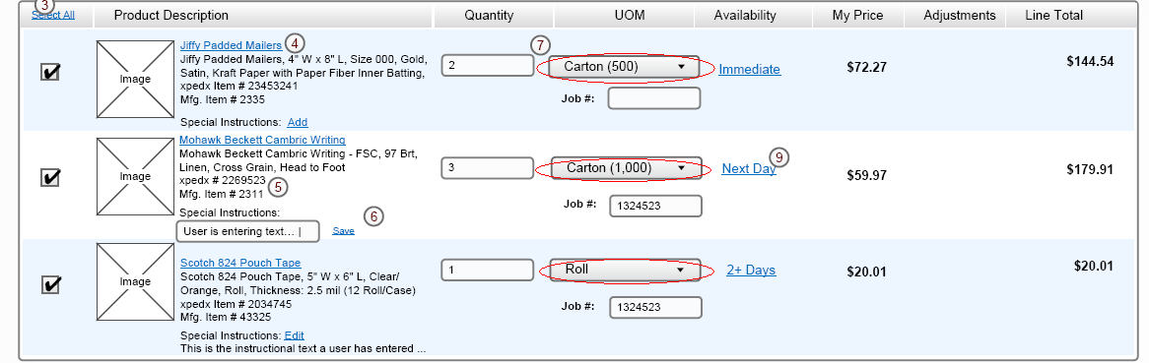

***UOM Drop down on My Item List:***

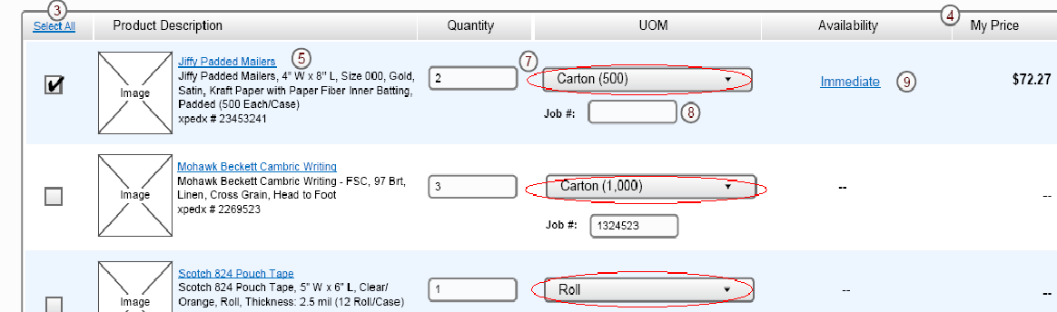

***UOM Drop down on Product Detail Page:***

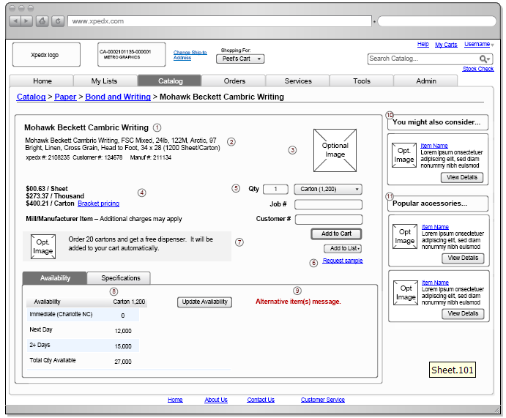

***Catalog ‘Lightbox’***

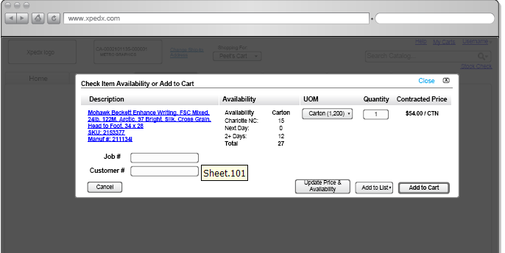

***UOM Drop down on Quick Add Page:***

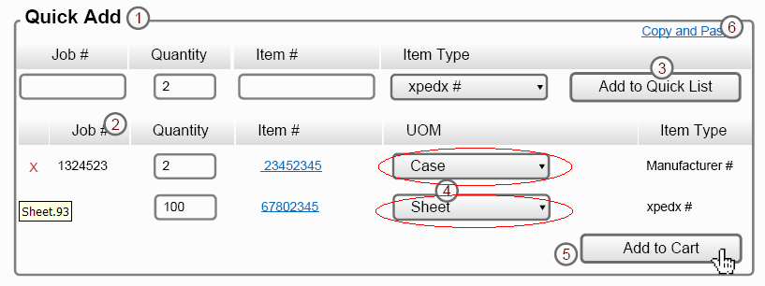

## Open Questions

1. What is the source of Pricing UOM? Answer: Price book is for price list. P&A is for contract price for the customers.
2. Scope for providing the ability to override UOM description for the Legacy-EDI UOMs needs to be revisited.
3. 2-digit Vs 3-digit UOM needs clarification – RESOLVED as all UOM will be 3 digits.
4. The logic for using the Customer Preferred UOM table still needs to be discussed for some scenario. Sent a scenario to George and Steve to discuss. Answer: They are fine with duplicate labels in the drop down based on the customer preferred uom logic.

## Assumptions

1. Conversion factors to convert and do the calculations for UOM should be present in the Sterling system.
2. Deletes for the UOM records for the Legacy – EDI batch data will be handled manually by xpedx (as per George).
3. Calculation and Presentation of UOMs are truly based on the rules specified in the document. Sterling will not do any exclusion or inclusion or cleaning of any UOM data on their end.
4. If the user changes Qty or UOM on the page then we need to do P & A to get the correct prices and availability based on the change.
5. Base UOM and Pricing UOM will not have multiple values for an item. In other words, there is always one Base UOM and one Pricing UOM for an item. P&A is returning the price in requested UOM and pricing UOM.
6. On order Change the UOM cannot be changed. The order shows the UOM (only one) which was selected at the time of order place.
7. There won’t be any screen to manage the customer preferred UOM table in Sterling for BR1. The data will be loaded as a manual data load exercise.
8. The table won’t have any record without a master customer value as blank.

# Glossary of Terms

|  |  |  |
| --- | --- | --- |
| S. No. | Term | Definition |
| 1. | Entity Object | Database and Java entity objects to store the required data. |
| 2. | Action Class | Struts controllers which redirects the parameters and does some business logic before calling the business APIs. |
| 3. | My Item List | Wish List of Items |
| 4. | BR1 | Business Release 1 |
| 5. | IW | Industrial Wisdom – UI firm engaged on the project. |
| 6. | Unit Of Measure | The unit of measure of the item |
|  |  |  |